720 N Price Road
Sugar Hill, GA 30518
678-288-9421
www.eliteawnings.net

Installation Instructions for Shade Sails

DISCLAIMER (Read carefully) The following installation suggestions are offered as a courtesy to mail order purchasers and to facilitate accurate ordering of the product. Shade Sails does not and cannot know the specific intentions of purchaser stress factors, variables for the area such as soil, wind condition and exposure, existing structure strength, local access codes, etc. The following is offered only as a highly generalized summary of installation methods used successfully by Shade Sails in the past. Shade Sails makes no extension of warranty by these general guidelines and disclaims any responsibility for the installation, design of installation, engineering requirements, code compliance or any other installation related matter. Shade Sails offers these services on an individual contract basis and purchaser has elected to purchase the ready-made sail only as a more economical alternative.
Make Them TIGHT!!
Nothing causes faster wear and tear than loose sails moving and banging in the wind. Most people don’t make them tight enough!!
Prior to installation, check with local authorities for any relevant building regulations which may exist, and check with the local utility companies for any underground services prior to digging holes for the support posts.
Selecting The Position:
Before you commence installation, it is very important that you consider the most suitable location for your shade sails. Take into account the following:
- Size of the shade sail(s);
- Strength of existing structures intended to be anchor points;
- Ability to insert suitable fixing posts;
- Location of barbecues;
- Sun direction;
- Wind speed and direction.
There could also be other factors specific to your situation which require consideration.
Note: Shade sails should not be used near an open flame. Do not use your barbecue under the shade structure.
In determining the location for your shade sail, it is important to keep in mind the movement of the sun across the sky throughout the day. The shade shadow of the sail will, of course, move as the sun moves. As a result, you will only have shade directly under the shade sail at midday during mid-summer.
Once you have identified the location for your shade sail, it is important to determine the most suitable mounting points for the corners.
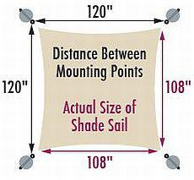
Some of these fixing points might already exist -- for example, a pergola, large tree, fence post, or fascia. If enough fixing points are not already available, posts may need to be installed. On each side of the sail, you should allow a space between the corner of the shade sail and the mounting point that is at about 10% of the shade sail's length. For example, if one side of the shade sail has a length of 120 inches, allow at least 12 inches of space between the corner of the shade sail and the mounting point. This will provide enough room for mounting hardware, material stretch, and tensioning of the sail. This should be done for each side of the shade sail to ensure there is adequate room to tension the sail properly.
This stage of the installation is critical. You should ensure all fixing points are structurally sound, and, if you are unsure, obtain independent advice from a builder or engineer.
Building Approvals:
Prior to installation, check with local authorities for any relevant building regulations which may exist.

Selecting Fixing Accessories:
There is an extensive range of fixing accessories available to help you secure your shade sails. These accessories are readily available from your hardware supplier.
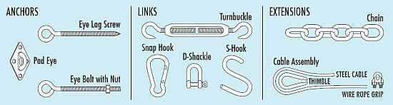
Chain, wire, or thick, strong rope can be used to extend your shade sail corner to a fixing point if required.

Select the fixing accessories which best suit your own installation.
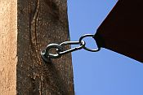  Spring Clip Connector | 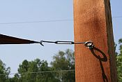  Turnbuckle Connector | 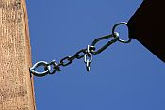  Chain Extension

Attaching To Fascia:
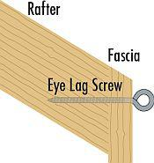
If you intend to fix your shade sails to a fascia, the use of a Fascia Support is strongly recommended. The fascia support is used to connect the overhangs of rafters or trusses to fascias ledgers giving a strong connection between the two for improved strength. Always make sure the fascia have been beefed up on the back side and attached to the rafters within 3 feet either side of the attachment point. With sails larger than 150 sqft, you should make sure the rafters have been screws, and not just nails. Simpson strong ties/hurricane hangers can be used to do this.
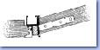  Use with Metal Fascias | 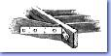  Use with Timber Fascias

Post Supports:
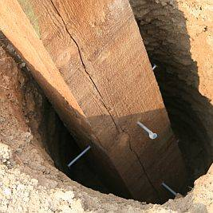
Click to Enlarge
If additional posts are required, we recommend the use of a minimum 4 inch, schedule 40 steel pipe or 6 inch x 6 inch treated softwood (H5 level treatment). Hardwood of durability class 1 should also be used. Your local timber supplier can assist you in selection. Post lengths should be calculated taking into account the proposed height of your sail plus the depth of your footings. The footing depth should be 1/2 the length of the exposed pole. For example, if your post height is to be 10 feet, you would use a 15 foot long post with a footing depth of 5 feet

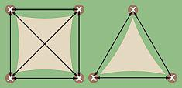 | Measure out centers of footing positions and mark as illustrated. Dig holes 16 inches square and to the depth required by the post height as described above.

Steel Post Footing
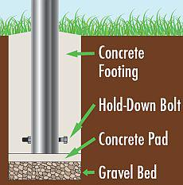 | Lay a 4 inch (100mm) depth of 3/4 inch diameter gravel at the base of the hole. Next, pour a 4 inch (100mrn) depth of concrete to provide a solid pad. Patio stones can be substituted in place of the poured concrete. Insert the post with a hold down bolt through the post to keep it secure. (see diagram) Pour the concrete footing and temporarily brace the posts until the concrete has set.

Wood Post Footing
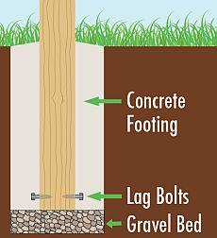 | Lay a 4 inch (100mm) depth of 3/4 inch diameter gravel at the base of the post. Insert the posts using lag bolts partially driven into the post to hold it in place. Use string lines to ensure they are in plumb alignment. Temporarily brace the posts until the concrete has set.

Concreting:
Mix concrete in line with the manufacturer's instructions. These will be labeled clearly on the packet. Your supplier will be able to give you any special advice you may require for your own conditions. Pour concrete to the top of the holes ensuring it is packed well. Ensure the concrete surface is sloping away from the posts to assist water drainage. Allow poles to set in concrete for a minimum of 48 hours. Brace if required.

Installation:
Connect fixing accessories to mounting points as required. Ensure all connections face towards the middle of the sail and are tightly secured. Check again to ensure all mounting points are solid.
Lay your shade sail out and commence the installation.

Tensioning:
Using the selected fixing accessories, commence connecting the corners of the shade sail to the fixing points.
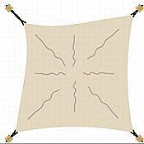  Tension Required | 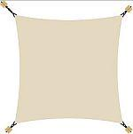  Tension Correct
A properly mounted and tensioned shade sail will have approximately 100 pounds of tension on it and will have few to no wrinkles. Connect all points, using rope or wire cable if necessary, to gain increased leverage. The rope can be threaded around a number of times so that it works as a "pulley" mechanism. Another tensioning method would be to use a turnbuckle which can aid in applying the proper amount of tension. Stop tensioning when the shade sail is rigid with few or no creases. CAUTION: Do not over tension. Tension only by hand and only tight enough to get the wrinkles out of the shade cloth. Re-tension periodically if required.
Warning:
Your shade sail is designed to provide UV protection and comfort in domestic areas. When selecting the position for your shade sail, ensure all fixing points are structurally sound and fixings are tightly secured. Inspect regularly. Prior to installing, consult your local council regarding building regulations which may apply in your area. Exposure to certain chemicals, e.g. Chlorine, can lead to the premature breakdown of the fabric. Chemicals to be used on or around the fabric should be referred to BackyardCity.com prior to their use.
Do not have fire or an open flame close to the fabric. Do not use your barbecue under the shade structure.
Care Instructions:
Your shade sails may be cleaned at any time using a solution of mild detergent and water. Apply the solution with a sponge or a very soft brush. Let the solution stand on the fabric for 10 minutes and rinse thoroughly with water from your garden hose.
DO NOT put the fabric in your washing machine, clothes drier, or scrub it with a stiff brush, scouring pad, or an abrasive cleaner.
The above is intended as a guide only and not the actual instructions for installing your shade sail. Please read and follow the manufacturer's instructions as it pertains to your particular shade sail.

